Topology Prelim (March 30, 1998)

Directions
Do all of the problems. Each problem is worth 10 points.
- Prove or disprove: The space drawn below can be contracted to a point in such a way that the point $x$ is fixed throughout the homotopy.
- 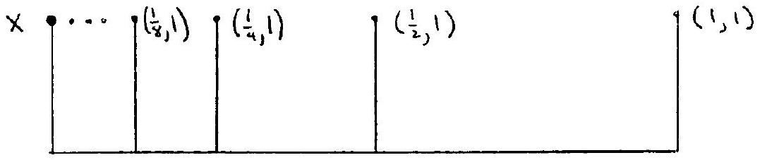
- Define an equivalence relation on $R^{2}$ by defining $(x,y)∼(z,w)$ if $xy=zw$. Is the quotient space Hausdorff?
- Prove that a retract of a Hausdorff space is closed.
- Let $X$ be the union of a torus and a disk as shown below. Compute $H_{*}(X)$.
- 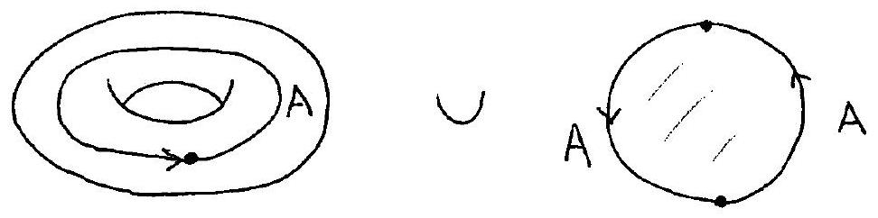
- State and prove the unique path lifting theorem for covering spaces.
- Compute $H_{0}(GL(2,R))$ where $GL(2,R)$ denotes the group of $2×2$ invertible matrices.
- Let $α$ be an embedded circle in a surface, $S$, of genus 2 such that $α$ separates $S$ into two components, each of which is homeomorphic to a punctured torus. Prove that $α$ is not null-homotopic.
- 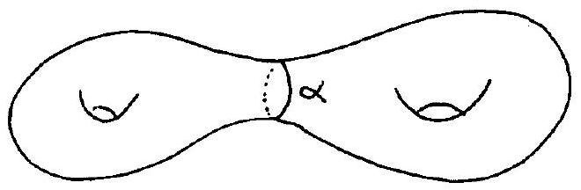
- Find a presentation for $π_{1}(S^{3}-k)$ where $k$ is the trefoil knot drawn below.
- 